The Helios Virtual Cockpit System is fantastic embellishment to several flight simulators, and this guide provides an overview and introduction to this system

Helios Users Guide

BlueFinBima Fork 1.4



Craig Courtney;BlueFinBima

©2011 SCSimulations, LLC

©2011 Craig Courtney

All trademarks and registered trademarks are the property of their respective owners.

© Copyright 2014 Craig Courtney

Helios is free software: you can redistribute it and/or modify it under the terms of the GNU General Public License as published by the Free Software Foundation, either version 3 of the License, or (at your option) any later version.

Helios is distributed in the hope that it will be useful, but WITHOUT ANY WARRANTY; without even the implied warranty of MERCHANTABILITY or FITNESS FOR A PARTICULAR PURPOSE. See the GNU General Public License for more details.

For the GNU General Public License, see <http://www.gnu.org/licenses/>.

|  |  |  |
| --- | --- | --- |
|  | **Version** | **Date** |
| Gadroc’s original Helios Users Guide | 1 | circa 6th March 2011 |
| First BlueFinBima Revision | 1.4 | 10th June 2019 |

# Introduction

Thank you for your purchase or interest in Helios. Helios has been over a year in the making and we hope you have as much fun flying with it as we’ve had making it a reality. Helios as a concept was born from some inspirational work of DickDastardly’s back in the middle of 2009. It has evolved tremendously and seen at least two user interface redesigns and hundreds of hours of development and testing. Thanks to everyone who has offered support both through encouragement and purchase. In addition I would be remiss in thanking my wife and family for putting up with me spending countless hours down in “the man cave”.

This manual should give you a general overview of how to use Helios both to edit and run profiles. While it may seem daunting at first but once you get the general concepts down you’ll be building amazing looking glass cockpits in no time. We would highly encourage you to join the forums at [www.scsimulations.com](http://www.scsimulations.com/) to ask any questions, share your work or just say hi. You’ll find tutorials and many great pilots who are always willing to help a fellow enthusiast.

Craig “Gadroc” Courtney *(Introduction retained from the V1 User’s guide -6th March 2011)*

At some point, Craig Courtney began a reworking of the Helios code, the goal was a little unclear, but this effort petered out and he decided to donate this fantastic undertaking to the Open Source community on GitHub. His instructions were to refer to it as Helios 1.5, however without being able to obtain Craig’s guidance, the fork that I pulled into the BlueFinBima repo along with Cylution’s MiG-21BIS interface I decided to refer to as 1.4 mainly to differentiate it from Craig’s 1.3 Master-work).All of the contributions thus far pail into insignificance compared with Craig’s original undertaking, and readers should continue to think of Helios being Craig’s endeavor with a few changes from others added on.

I began work on the BlueFinBima fork following my purchase of the Harrier AV-8B NA, and I decided to attempt to write my own dedicated Helios interface for that aircraft. I quickly found out how challenging & time consuming writing the interface, and creating a profile with graphics can be. Since then, I progressed on to creating an interface for the F/A-18C hornet and modifying CaptZeen’s Hornet profile to talk to the dedicated Helios interface.

Time is a scarce resource, and with only a small number of contributors to the project, progress is very slow, and it is likely to continue to be this way. This said, I will endeavor to make updates available as and when the opportunity arises.

“BlueFinBima” June 2019

**Table of Contents**

Introduction 3

System Requirements 5

Operating System 5

Hard Drive 5

Memory 5

CPU 5

Video Card 6

Input 7

Installation and System Setup 8

Installation 8

File System Layout 8

Touch Screen Setup 10

Terms and Concepts 13

Controls 13

Panels 13

Interfaces 13

Triggers 13

Actions 13

Bindings 13

Gauge Packs and Modules 14

Control Center 12

Starting Control Center 12

Selecting a Profile 13

Starting a Profile 13

Resetting a Profile 13

Deleting a Profile 13

Closing Control Center 13

Setting Preferences 14

Profile Editor 16

Creating a New Profile 17

bSaving and Loading Profiles 17

Navigating Your Profile 17

Adding, Editing and Removing Controls 20

Using the Layers Tool Panel 25

Templates 22

Add & Removing Interfaces 23

Bindings 24

# System Requirements

Helios system requirements will vary based on how you are using it and what simulation you are running. Displaying switches and indicator lights does not take many resources while displaying 10-20 continuously updating gauges will have a much greater impact on your system.

## Operating System

### Windows 7 x64 with .net 4.5

Helios is designed and developed for Windows 7 and above. It is tested on and 64bit versions of the operating system. There is nothing in the software which should prevent it from running on Windows XP with .Net 4.5 installed, but it is an untested and unsupported configuration.

## Hard Drive

### 20 MB (1.5GB including .Net 4.5)

Helios has a relatively small footprint, but does require .Net 4.5 to be installed first. .Net 4.5 can take up to 1.5 GB of disk space on a 64 bit system, but is only installed once for all applications to use it. It is most likely already installed on your system. Disk usage has not been assessed for Helios 1.4.

## Memory

### 2GB Minimum (4 GB Recommended)

The amount of memory Helios consumes is directly related to the number of controls and size of your screens. An average profile will take about 100-200 MB of ram. This amount of memory should be added on top of what is required for your simulation.

*Note: In order to use more than 3GB of ram you must be using a 64bit operating system. Currently Helios 1.4 is only compiled for 64 bit, however a 32 bit version is being considered.*

## CPU

### Dual core 2.4 Ghz (Core2Duo or newer)

Helios does not require much CPU, but it does need to run at the same time as your simulation. If your simulation is consuming 75% or more of your CPU before running Helios you may need to reduce some simulation settings to prevent FPS impact. An alternative is to run Helios on another PC.

## Video Card

### Simulation Dependent

Helios will take on average 75-100MB of video ram, although this is very dependent on what you put into the profiles and the size of the images you use. This video ram is in addition to what your simulation uses. If your card is fully consumed with the simulation, you may need to balance some of the graphics settings inside your simulation and the amount of data and size of graphics you use in your Helios profile to maintain smooth game play.

An alternative is to run Helios Control Center on a second PC.

## Input

Helios will work with any device which appears as a mouse or touchscreen to windows.

# Installation and System Setup

## Installation

To install Helios just download the latest version of Helios from <https://www.digitalcombatsimulator.com/en/files/3302014/> . The setup application will check for any necessary pre-requisites and prompt you if you need to install anything before Helios. Helios installation also delivers two other programs, one for exporting screen sections over a network, and one for keystrokes over the network. Both of these can be used when running Helios Control Center on a second PC.

## File System Layout

The first time Helios runs it will create a directory name “Helios” under your My Documents directory. This is where Helios will store all your configuration, profile and images.

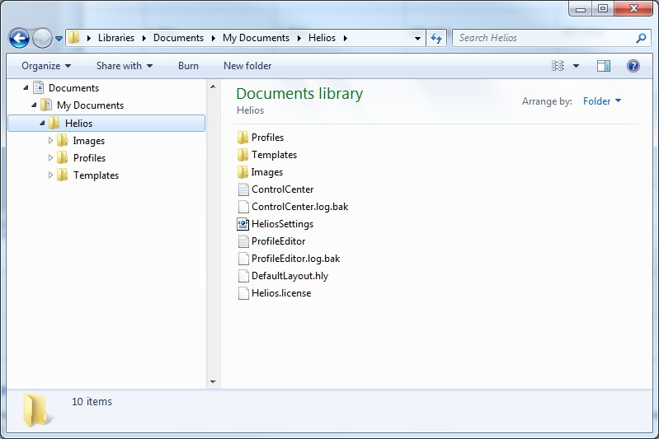

**ControlCenter.log/ControlCenter.log.bak**- This file contains log information about what Helios Control Center is currently doing and the last time it was run. You may be asked to send this file for support.

**ProfileEditor.log/ProfileEditor.log.bak**- This file contains log information about what Helios Profile Editor is currently doing and the last time it was run. You may be asked to send this file for support.

**HeliosSettings.xml** – This file contains defaults and configurations for Control Center and Profile Editor. You can delete this file to reset configuration to defaults.

**DefaultLayout.hly**– This file contains your saved default layout for the profile editor.

### Profiles

This directory is where Control Center will look for the list of profiles. Each profile will have up to three files in this directory.

**\*.hpf**– This is the actual profile and is the only file needed to run the profile.

**\*.bak**– This is a backup of the profile which is copied every time you save the profile in the Profile Editor. If for some reason your profile gets corrupted you can try renaming this file.

**\*.layout**– This is the layout of the Profile Editor window which was saved last time you saved the profile.

**\***.hply – This is a newer version of the layout used by the Profile Editor window manager to show the layout from the last time the profile was saved.

### Templates

This directory and its sub-directories contain the your saved templates.

### Images

This directory is where you should place all of your custom images you use inside your profile.

## Touch Screen Setup

Windows 7 has great built in support for touch screens, but not all of the default options work well with Helios. It is highly recommended that you follow these instructions to property setup your touch screens for Helios.

Note: Not all monitors are recognized as touch screens by Windows. If your touch screens do not respond to these settings, but still work to move your mouse around you need to follow the manufacturer’s directions for setting up and calibrating your touch screen. In particular TouchKit based controls do not require these steps. For some touch screens, a mouse event can be triggered following a touch event, and there is an option in the Helios Control Center preferences which will allow mouse events to be ignored for a period of time following a touch event. This is not always necessary.

### Associate Touch Screen with Monitor

Windows needs to understand which monitor is your touch screen. If your mouse moves on another screen when you click on your touch screen you need to execute this step.

* + - 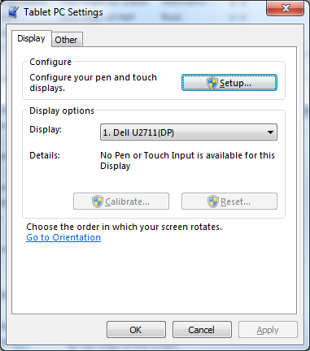From the start menu select “Control Panel” then open the “Tablet PC Settings” control panel.
    - Click on the Setup button and follow the instructions on screen. Take special note to press enter without tapping your touchscreen when the message is displayed on normal bmonitors.

### Disable Input Panel Tab

Windows 7 has features to help you use your touch screen as a primary input device. Unfortunately these can get in the way and cause problems when using Helios to play a game. We can disable this input panel tab to prevent it from showing up when we don’t want it.

* + - 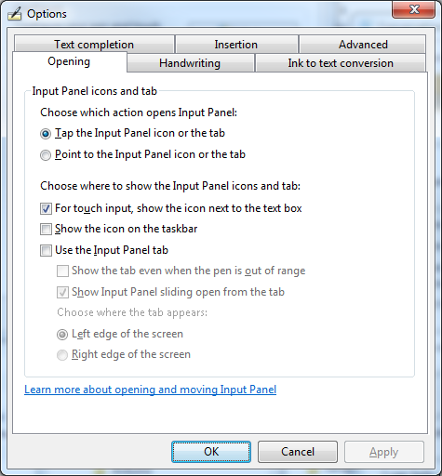While you have the “Table PC Settings” window open, click on the tab labeled “Other” and then click on “Go to Input Panel Settings”.
    - Now uncheck the “Use the Input Panel tab” option and click the Ok button.

### Disable Auto Right Click

By default Windows right clicks when you touch and hold on a touch screen. This is great for interacting with Windows explorer or other regular applications, but causes problems when you are trying to hold down a lamp test or MFD button. Luckily we can change this behavior as well.

* + - 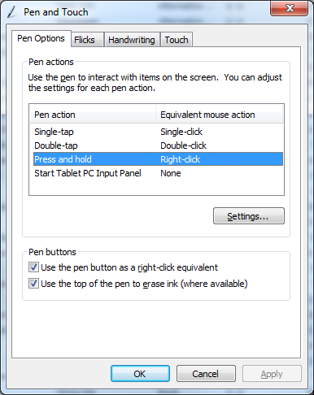From the start menu select “Control Panel” then open the “Pen and Touch” control panel.
    - On the Pen Options tab click on the Press and Hold pen action and then click on the “Settings” button.
    - Uncheck “Enable press and hold for right- clicking” then click the OK button.
    - Switch to the Flicks tab and uncheck the “Use flicks to perform common actions quickly and easily”. You can also uncheck “Display flicks icon in the notification area” if you want.
    - Next, switch to the Touch tab.
    - Click on the Press and hold touch action and then click on the “Settings” button.
    - Uncheck “Enable press and hold for right- clicking” and then click the OK button.
    - Now close the Pen and Touch control panel by clicking the OK button.

# Terms and Concepts

Helios has a few key concepts which you should understand in order to build and modify profiles.

## Controls

Controls are the glass cockpit items that Helios renders and allow you to interact with the simulation through Helios. These range from simple text labels to clickable/touchable switches to full simulated gauges.

## Panels

Panels are containers for controls. A panel can have multiple controls on it which will all be moved and hidden when the panel is moved. Panels may be nested inside of each other.

## Interfaces

Interfaces are connectors which allow Helios to interact with other software and accept hardware based physical inputs. The most common interfaces you will use are the simulation interfaces (DCS, Falcon, etc…) and keyboard.

## Triggers

Helios is constantly monitoring what is happening with all of its interfaces and controls. When Helios detects something has happened that you may want to know about or which may affect displays, gauges or the simulation it fires of a Trigger. Each interface and control can expose a set of triggers relevant to its operation. The simulation interfaces expose the state of the aircraft and its instruments as triggers and controls expose triggers for changes in switch and button position. Triggers often supply giving you the value which triggered the change.

## Actions

Actions represent the ability for Helios to supply input or change the state of controls and interfaces. Gauge controls expose actions which set their needles position and simulations expose actions to press buttons and flip switches. Many actions take a value as input.

## Bindings

Bindings are how you tell Helios what to do when a trigger is fired. Bindings associate an action which you want to occur when a trigger fires.

## Gauge Packs and Modules

Gauge Packs and Modules are add-ins which supplies additional Controls and Interfaces for use in Helios profiles. These are usually licensed separately.

Note: The concept of Gauge Packs appears to have been deprecated with the move to Open Source.

# Control Center

Control Center is the primary tool you will use to find start and stop profiles.

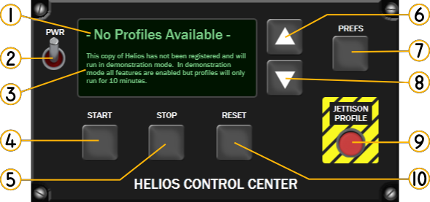

1. Profile Name – Displays the name of the currently selected profile.
2. Power Button – Clicking this minimizes the Control Center to the taskbar.
3. Status Message – Displays the current status of the Control Center. Helios will prompt you for any actions and alert you to error conditions here.
4. Start Button – Clicking this button will start running the currently selected profile.
5. Stop Button – Clicking this button will stop the currently running profile.
6. Previous Button – Selects the previous profile. If a profile is running when a new profile is selected it will be automatically stopped.
7. Preferences Button – Clicking this button will display the control center preferences.
8. Next button – Selects the next profile. If a profile is running when a new profile is selected it will be automatically stopped.
9. Delete Button – Clicking this button will delete the currently selected profile. You must confirmthedeletebyclickingthestartbuttonwhenpromptedbythestatusmessage.
10. Reset Button – Clicking this button will reset the currently selected profile to default state.

## Starting Control Center

You can start control center by clicking on it in the start menu. Helios Control Center can be found under Gadroc’s Workshop .

## Selecting a Profile

Control Center loads the list of all profile you have saved in your My Documents/Helios/Profiles directory. You can cycle through them in alphabetical order using the previous and next buttons. The current profiles name will be displayed on the control center.

## Starting a Profile

To start a profile you must first select the profile using the next and previous buttons. Once the profile name you want to start is displayed in Control Center click the start button.

Profiles can also be started through windows explorer by right clicking on a profile and selecting Run.

## Resetting a Profile

Sometimes it’s necessary to reset a profile to its default state. To reset your profile just click the reset button on the control center window. This is especially useful if you are flying a simulation without full integration and you need to restart a flight. For simulations which have full integration it will also request a full re-sync with the simulation.

Profiles can be reset while stopped or running. Profiles are automatically reset if they are reloaded due to a newer version being available when the start button is pressed or when cycling through profiles with the previous and next buttons.

## Deleting a Profile

Profiles can be deleted while in the control center. First make sure the profile you want to delete is selected and then click the Jettison Profile button. Helios will prompt you to click the start button in order to confirm you want to delete the profile. Clicking any other button besides start will cancel the delete.

You can also delete profiles by deleting them through Windows Explorer. Just find the profile in your My Documents/Helios/Profiles directory and drag it to the trash.

## Closing Control Center

Control Center is designed to run in the background and will normally minimize itself to the taskbar instead of exiting. You can tell Helios to close all together by right clicking on the taskbar icon and selecting the “Exit Control Center” task.

## Setting Preferences

Control Center preferences are opened and closed by clicking on the preferences button on the main screen.

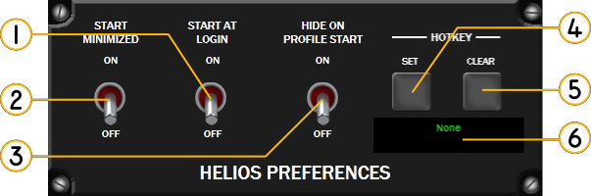bbbbbbbbbbbbbbbbb

1. Start At Login – When set to on Helios will automatically load every time you log into your system.
2. Start Minimized – When set to on Helios will start minimized to the taskbar.
3. Hide on Profile Start – When set to on Helios will automatically minimize itself whenever a profile is started.
4. HotKey Set – Clicking this button will allow you to set the hotkey which will bring Helios to the top of the screen.
5. HotKey Clear – Clicking this button will remove the currently set hotkey.
6. HotKey – This displays the currently set hotkey. When this hotkey is pressed Helios will be brought to the top off all windows on the screen.

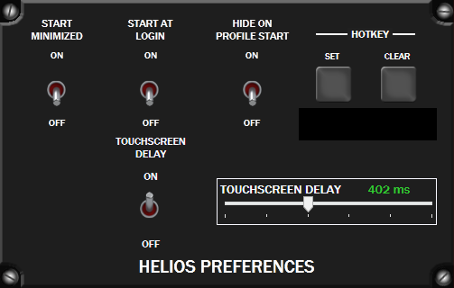

Figure 1 Helios Control Center 1.4 Preferences Screen

# Profile Editor

Helios Profile Editor allows you to construct your own profiles or customize the samples profiles you can download. Profile editor can be found under Gadroc Workshop/Helios in your start menu. The default layout for the profile editor is shown below.

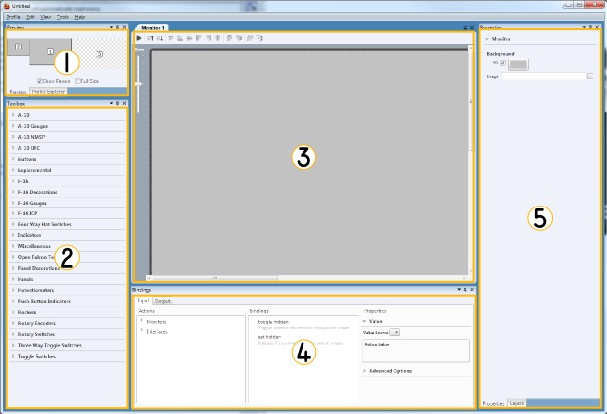

1. Profile Preview and Explorer – These tool panels allow you to navigate through your profile. Preview shows a miniature version of your entire profile across all monitors. Double clicking on a screen will open it for editing in the editor tabs. Profile Explorer shows you a tree view of all monitors, panels, controls and interfaces in your profile. Double clicking on any of them will open the correct editor in the editortabs.
2. Toolbox – This tool panel has all the available controls which you can drag onto yourprofile. You will also find controls which you have saved as customtemplates.
3. Editor Area – This is the primary editing area. All items which you can edit will open in this area as separate tabs.
4. Bindings Editor – This tool panel will allow you to bind both inputs and outputs to the currently selected control from the editortabs.
5. Properties and Layers – The properties tool panel allows you to see and change the properties for the currently selected control from the editor tabs. These properties let you change the behavior and look of the control. The layers tool panel allows you to control which controls are visible, there display order and whether they are locked to prevent changes.

## Creating a New Profile

To start a new profile in the editor select new from the Profile menu or use the hotkey CTRL-N. New profiles start with the current PCs monitor configuration along with the Profile and Keyboard interfaces added by default.

## Saving and Loading Profiles

To save a profile select Save from the Profile menu. If you have not already saved this profile before you will be prompted for a filename and location. Helios defaults to saving all profiles in the My Documents/Helios/Profiles directory. This is the only directory which control center looks for profiles.

You can also save a copy of an existing profile by using the Save As menu item. This will prompt you for a new filename to use. All additional save commands in this session will save to the new file.

Helios will remember which items you where editing in the profile and next time you open the profile for editing you will be right where you left off.

You can load any existing profiles by selecting Open from the Profile menu. If your current changes have not been saved you will be prompted to do so. Profiles can also be loaded into the editor by right clicking on them in Windows Explorer and selecting Edit from the menu.

## Navigating Your Profile

You can navigate through your profile in two ways. You can use the profile preview or the profile explorer to open items for editing.

### 

### Profile Preview

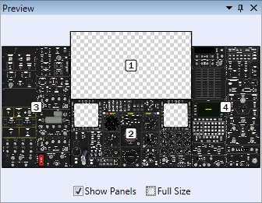The profile preview tool panel shows you miniature view of your profile across all of your monitors. Each monitor will be labeled with a number. Double clicking on a monitor will open that monitor as a tab in the editing area.

The preview tool has two check boxes at the bottom which allow you to change the way it looks. First is the Show Panels option which allows you to toggle whether the preview only displays the monitor outlines or it renders the panels as well. Second is the Full Size option, which when check will change the preview to

be a zoom able full size view. When uncheck the preview will automatically zoom to fit in the preview area.

### Profile Explorer

Profile explorer is a tree view of all the monitors, panels and interfaces currently included in this profile. Double clicking on any item in the profile explorer will open its tab in the editor area.

## Adding, Editing and Removing Controls

Helios can display controls on any of your attached monitors. To open monitors and panels for editing double click on it in either the Preview or Profile Explorer tool panels. The monitor or panel will show up as a tab in the editor area. The editor has several toolbar buttons and controls as shown below.

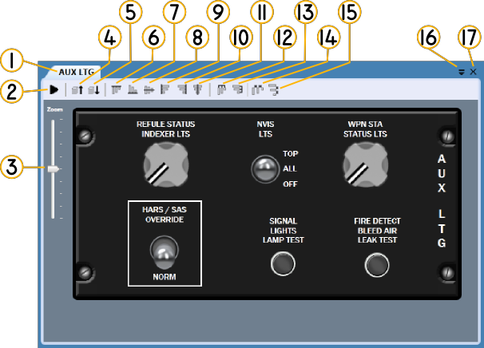

* 1. Panel or MonitorName
  2. PreviewButton
  3. ZoomControl
  4. MoveUp
  5. MoveDown
  6. AlignTop
  7. AlignBottom
  8. Align VerticalCenter
  9. AlignLeft

### Setting Monitor Properties

* 1. AlignRight
  2. Align HorizontalCenter
  3. Distribute On HorizontalCenter
  4. Distribute On VerticalCenter
  5. Space EvenlyHorizontally
  6. Space EvenlyVertically
  7. Tab List
  8. CloseTab

Monitors can be set to have a background fill color and/or a background image. These can be used hide any other windows or desktop backgrounds. To set the fill and background image properties for a monitor, select the Monitor’s tab and then deselect all controls by pressing the ESC key.

### Adding Controls

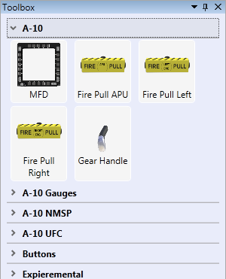You will find all of your available controls in the Toolbox tool panel on the left side of the screen. You can expand and collapse the categories by clicking on the category name. To add the control to you the monitor click the picture or title of the control and drag it into the editor.

While dragging the controls onto the editor they will automatically snap align to existing controls already in the editor. To disable this snap hold down the Control key while dragging.

Once you drop a control onto the editor it will automatically be selected and you can immediately change its behavior or appearance by changing the values in the Properties tool panel.

### Selecting Controls

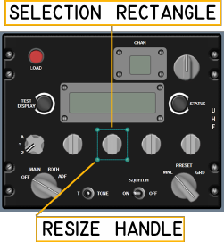Clicking on control or panel will select it, once selected you will see a rectangle with round resize handles surrounding the control. Once a control is selected the properties panel will display all available properties for this control. The selection rectangle will be blue while the editor has focus and gray while it does not.

Holding the control key while clicking additional controls will allow you to select multiple controls. You can also click and drag on the background select a region of controls. When multiple controls are selected you cannot edit any properties.

### Moving Controls

Controls can be moved around the editing area by first

selecting the control or controls to be moved. Next click and drag anywhere inside the selection border. While moving controls Helios automatically snaps to the border of other controls. Press and hold the control key while moving a control to prevent it from snapping.

You can also you the keyboard arrow keys to move the selected controls one pixel at a time. Keyboard commands will only work while the editor has focus and the selection rectangle is visible and blue.

### Resizing Controls

Controls can be resized by clicking and dragging on the resize handles. While resizing Helios will automatically snap to other controls, but you can disable this by holding down the control key while resizing. To maintain a controls aspect ratio (its height relative to its width) hold down the shift key while resizing.

### Aligning & Distributing Controls

Helios has several tools which make it easy to line up and evenly distribute your controls so your panels look great. You can find all of the alignment and distribute functions on the editor tab toolbar.

To use the align functions first select the control which you want to align to. Next hold down control and select the controls which you want moved. Finally click the alignment option you want.

* + - Align Left – Moves all selected controls so their left hand side aligns to the first selectedcontrol.
    - Align Right – Moves all selected controls so their left hand side aligns to the firstselected control.
    - Align Horizontal Center – Moves all selected controls so they are centered right to left with the first selectedcontrol.
    - Align Top – Moves all selected controls so their top side aligns to the first selectedcontrol.
    - Align Bottom – Moves all selected controls so their bottom side aligns to the first selected control.
    - Align Vertical Center – Moves all selected controls so they are centered top to bottom with the first selectedcontrol.

To use the distribute functions controls evenly select all of the controls you want distributed. Helios will select the two most outside controls and distribute the rest evenly between them.

* + - Distribute On Horizontal Center – This will distribute the controls so their left to right center points are evenly spaced. If the controls are different widths the empty space between controls will vary. This does not change the vertical positioning of thecontrols.
    - Distribute On Vertical Center – This will distribute the controls so their top to bottom center points are evenly spaced. If the controls are different heights the empty space between controls will vary. This does not change the horizontal positioning of thecontrols.
    - Space Evenly Horizontally – This will distribute controls from left to right so that there is equal empty space between controls. This does not change the vertical positioning of thecontrols.
    - Space Evenly Vertically – This will distribute controls from top to bottom so that there is equal empty space between controls. This does not change the horizontal positioning of thecontrols.

### Changing Draw Order

When Helios draws controls on the screen it does so in draw order. This order goes from bottom to top, so things on top of the draw order are last to be drawn and look like they are on top of the others.

When you drag or paste a control into the editor it is placed at the top of the draw order. Normally this works fine and you don’t have to change anything, but sometimes it’s necessary to change the draw order after you are editing.

You can modify a controls position in the draw order by first selecting the controls you want to change then clicking on the move up or move down toolbar icons. When you click move up the selected controls will be moved up one position in the draw order making them draw over top of more controls. Move down will move the selected controls one position down in the draw order making other controls

draw on top of them. Sometimes it’s necessary to move the control several times if you are trying to get it on top of something high up or down low on the draw order.

### Removing Controls

Controls can be removed by first selecting them and then either pressing the delete key on the keyboard or selecting delete from the edit menu.

### Editing Panels

Panels can be moved and resized just like all other controls. In order add controls to a panel or modify one already on it double click the panel in either the profile explorer or in the editor area.

When a panel is resized while the shift key is held down it will atomically scale all of its children controls as well. If a panel is resized without the shift key its children will remain the same size, but be moved if necessary to remain on the panel.

When a panel is removed all of its children controls are also removed from the profile.

## Using the Layers Tool Panel

Complex panels can end up with several dozen controls which can be difficult modify. The layers tool panel allows you to have a definitive view of the draw order and control which controls are displayed and locked.

* + 1. 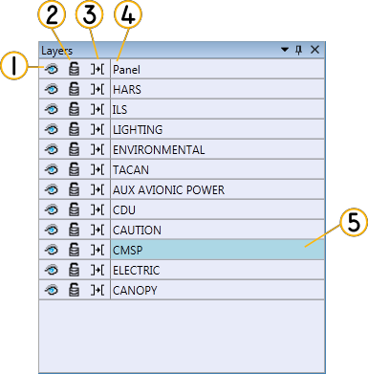Visible – The eye icon toggles whether the control is drawn in the editor. When the eye is open the control is visible and when it is closed the control is notdrawn.
    2. Locked – The lock icon toggles whether the control can be selected or modified. When locked you will not be able to select the control in either the editor window or the layout tool panel.
    3. Snap Target – This icon toggles whether other controls will snap to this one when they are dragged or resized. When the icon shows an arrow this control will be a snap target.
    4. Control Name – You can select controls by clicking on the name. Hold down the control key to select multiplecontrols.
    5. Selection Highlight – When a control is selected its background will changecolors.

## Templates

Many times while you are creating a profile you will have several of the same type of switch or panel graphics. Templates allow you to save a control which you have already configured so you can easily replicate it over and over again. Once you have created a template it will show up in your toolbox and you can add it to your profile just like every other control.

### Creating a Template

When you have configured your control the way you want it make sure it is selected. You can only have one control selected when creating a template. Once you have the control selected select Save as Template from the Tools menu. Helios will prompt you for a name and category for this template. The category will be the heading in the toolbox this control is found under.

All properties except for bindings will be saved with your template.

### Editing & Removing Templates

You can rename and delete controls after you have created them by using the Template Manager. Open the template manager by selecting it under the Tools menu.

To rename or control or move it between categories select it from the list on the left hand side of the Template Manager window. Change the name or category on the right hand side and click save.

To delete a template select it from the list on the left hand side of the Template Manager window then click the delete button.

## Add & Removing Interfaces

Interfaces allow a Helios profile to talk with other applications and hardware. In order to use an interface it must be added to the profile and sometimes configured. Helios comes with several interfaces out of the box which you can use in your profile. Please reference the Interface Guide for more details on using each of them.

By default Helios will add the Keyboard and Profile interfaces to all new profiles. The keyboard interface allows Helios to act like a keyboard so you can send commands to other applications. The profile interface allows you to interact with Helios to start and stop profiles and show the control center.

### Adding Interfaces

You add interfaces to your profile by selecting Add Interface from the Profile menu. Helios will present you with a list of available interfaces. Select the interface you want to add and click the add button.

Helios will only present the interfaces that are available to you based on your license, hardware attached to your machine and what interfaces are already in the profile (some interfaces have to be unique in a profile while others can be added multiple times). When an interface which has configuration options is added to the profile will automatically open its configuration screen.

### Configuring Interfaces

Many interfaces have configuration options. Interface configuration screens open inside the primary editing area alongside monitors and panels. You can reopen the configuration tab after closing it by double-clicking on the interface name in the profile explorer.

### Removing Interfaces

You can remove interfaces from your profile by selecting them in the profile explorer then pressing delete or selecting delete from the edit menu.

*Note: Removing an interface will remove all bindings you have made to it. Helios will prompt you before completing the removal.*

## Bindings

Bindings allow you to tell Helios what to do when trigger conditions occur. Input bindings are bindings which execute actions on the currently selected control, monitor or interface. Output bindings are bindings which fire based on triggers from the currently selected control, monitor or interface.

Bindings can be added, edited and removed using the binding tool panel. The binding tool panel will display the bindings for the currently selected control or interface.

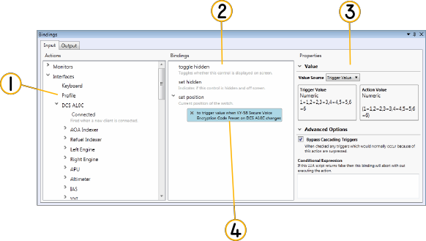

1. Trigger/Action Source List – This area lists all available triggers for input bindings or actions for outputbindings.
2. Binding Points – This area lists all the available binding points for the currently selected control orinterface.
3. Binding Properties – This area lets you configure the value passed into the action for this bindings and set advanced options. If the currently selected binding does not accept input values only advanced options will bedisplayed.
4. Binding – Already established bindings will be listed underneath their respective binding point. The currently selected binding will be highlighted blue and its properties will be displayed in the bindings propertyarea.

### Add Bindings

First select the control or open the configuration screen for the interface which you want to bind to. Next make sure you have selected the appropriate input or output tab. Next find the trigger or action in the list and drag it to binding point. A new binding will be added and selected.

### Remove Binding

Select the binding you want to remove and press delete on the keyboard, select delete from the edit menu or click the x button to the left of the binding description.

### Setting Value Source

When an action accepts an input value you will have three options on how to supply it.

#### Static Value

Static values use the same value every time the binding is executed. Whatever is entered into the text box will be passed to the target action. Different actions require different kinds of input so please read the action value type and any help text which may be present.

#### Trigger Value

Trigger value passes the value supply by the trigger straight into the action. Helios will auto convert many units of measure for you when using this option, but if it cannot you will get a warning message.

#### Lua Script

This option allows you to use lua to calculate or modify the trigger value before passing it to the action. Helios will use the first return value from the lua expression for the action. You have access to the trigger output value with the global variable named “TriggerValue”.

### Advanced Options

Advanced options allow you to create some more advanced behaviors with your profile.

#### Bypass Cascading Triggers

Many times when you execute an action via a binding it will also fire several triggers. Sometimes this is not desirable check this checkbox. When checked Helios will not fire any output bindings which may normally trigger when executing the action.

#### Condition

This is a lua expression you can use to prevent a binding from firing based on logic in the lua expression. Helios evaluates this script every time this binding executes. If the first return value evaluates to false then the binding will be aborted and the action will not be called.

### Common Actions

All controls share a few common actions.

#### Toggle Hidden

This action toggles whether the given control will be displayed or not. No input value is accepted.

#### Set Hidden

This action sets whether the given control will be displayed. If the input value evaluates to true it will hide the control otherwise the control will be visible.